Starting a Project

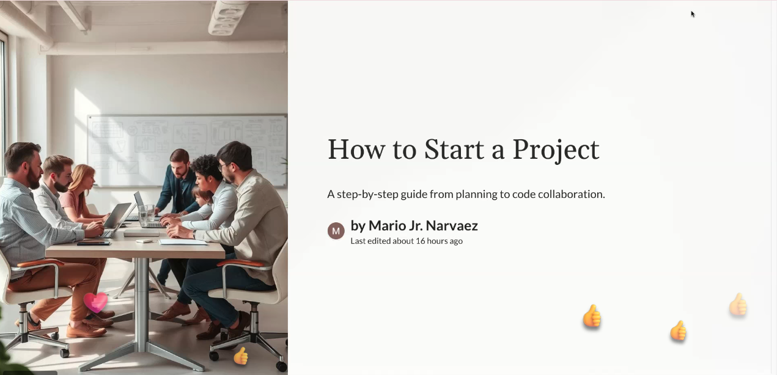

Ecommerce site: project

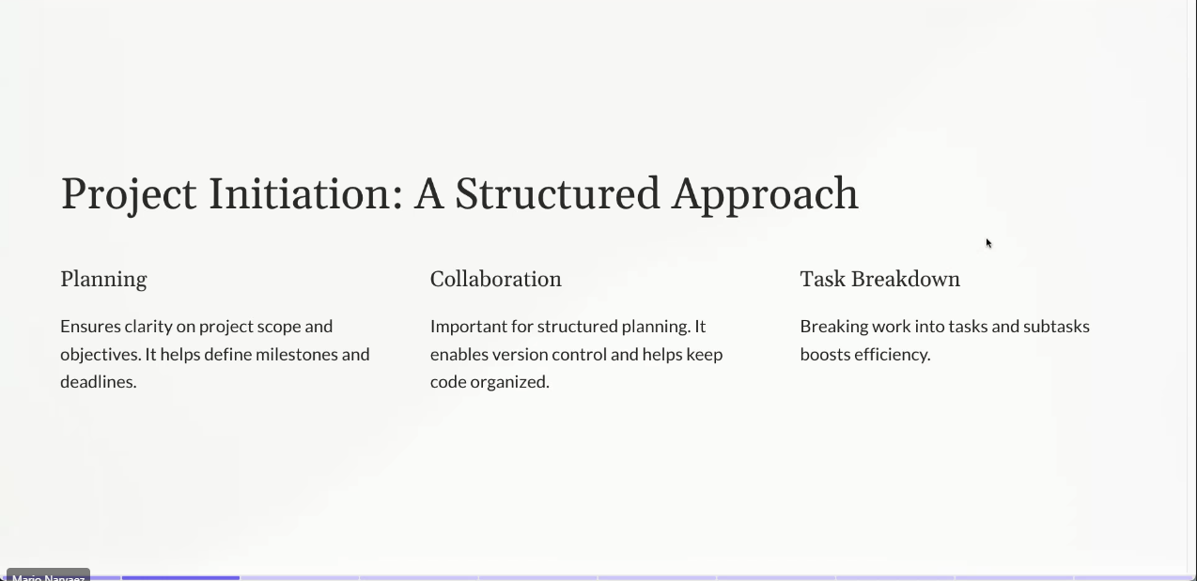

<https://www.atlassian.com/blog/project-management/project-milestones>

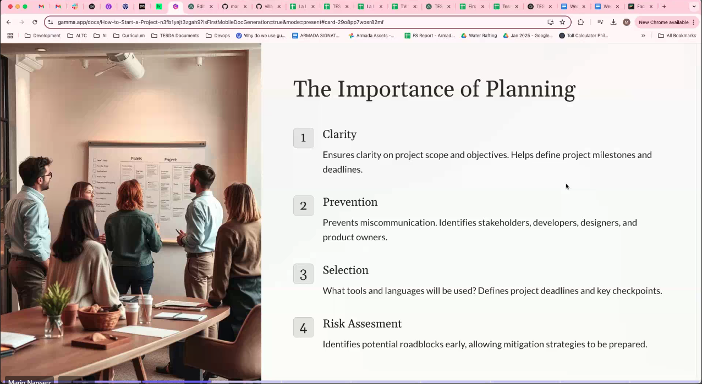

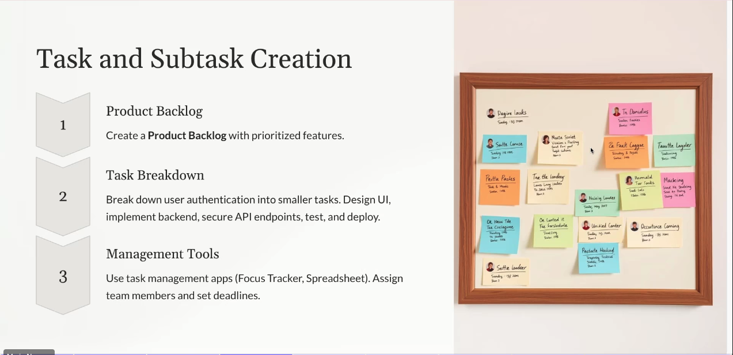

Have task breakdown on the group, proj manager (spreadsheet)

Set deadline

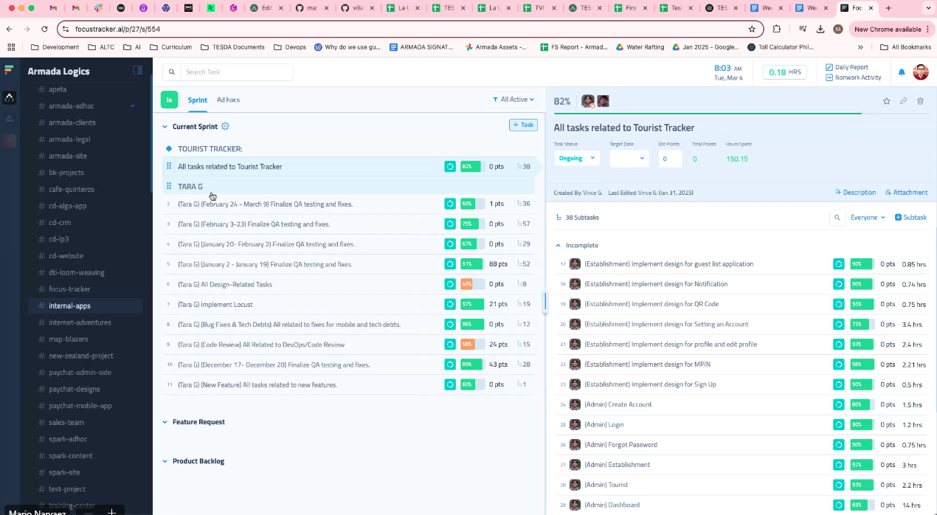

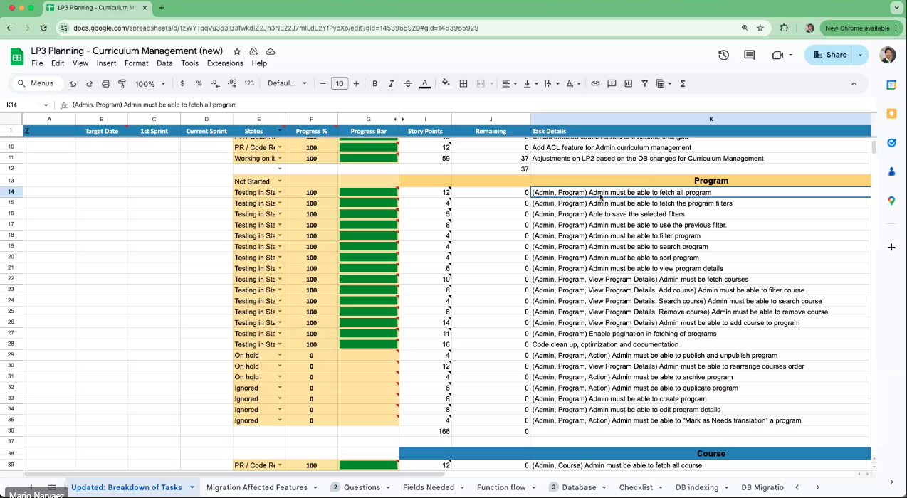

Progress: ongoing, pending done

To-do, in progress, done

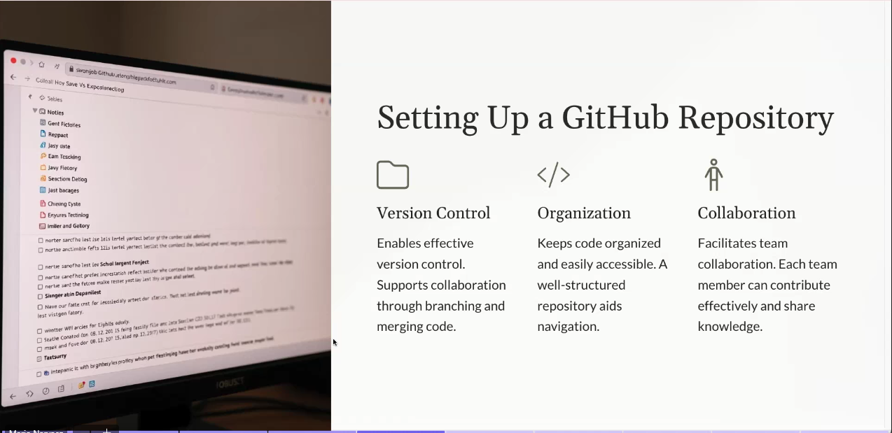

Mario:Main repo – process push only no pull

Mario:Develop repo – make exact copy of main repo, lahat ng forks dapat may develop branch and magbranchout ng feature branch

Mario:Ecommerce-Dashboard-Page-Branch

* Code here
* Commit and push (?)

Roby:Main

Roby:Develop

Roby:Ecommerce-Product

Develop

* Pull from it then branchout dun kayo magcode

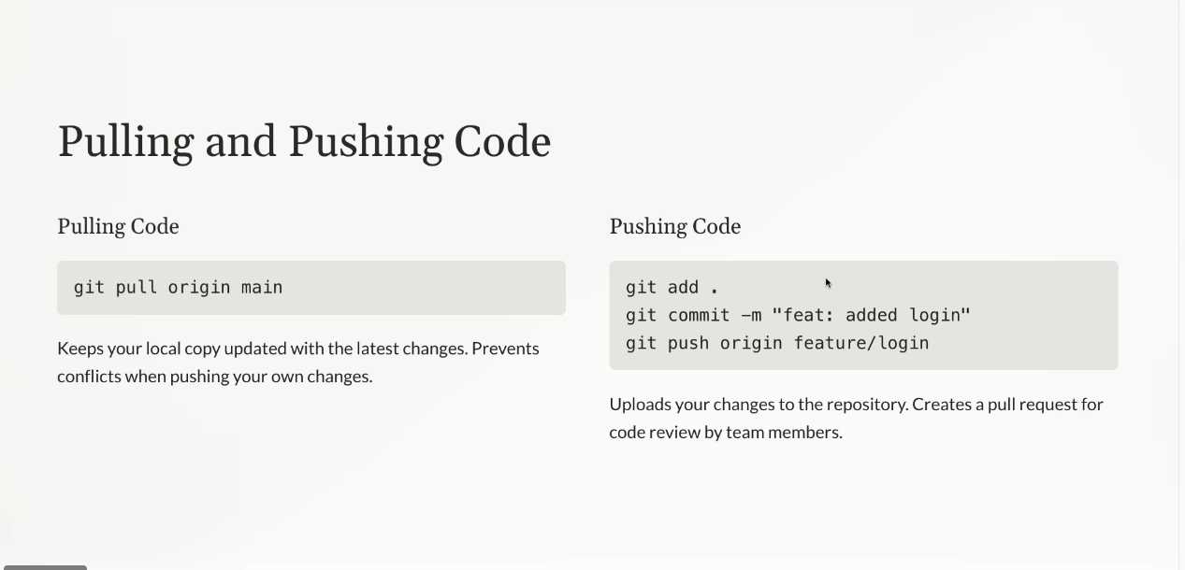

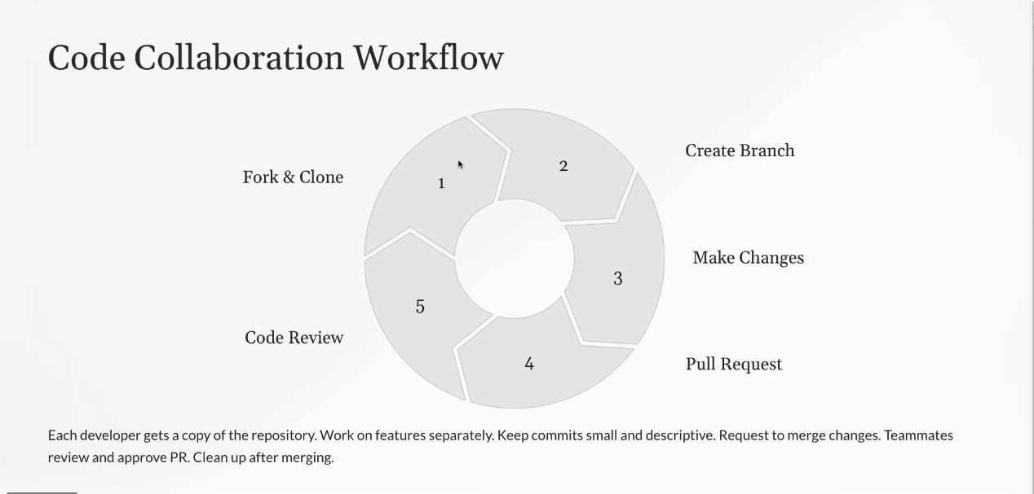

Pull request to develop branch

Code review

Then merge

Pull all members

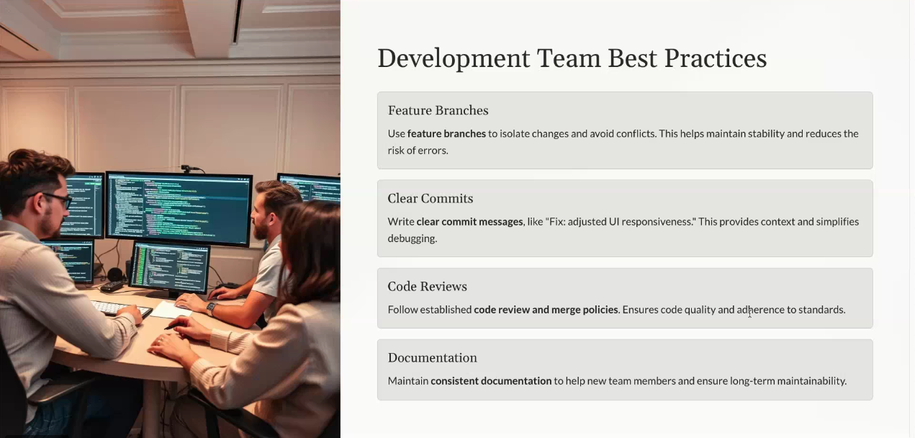

Documentation (extra mile, not required)

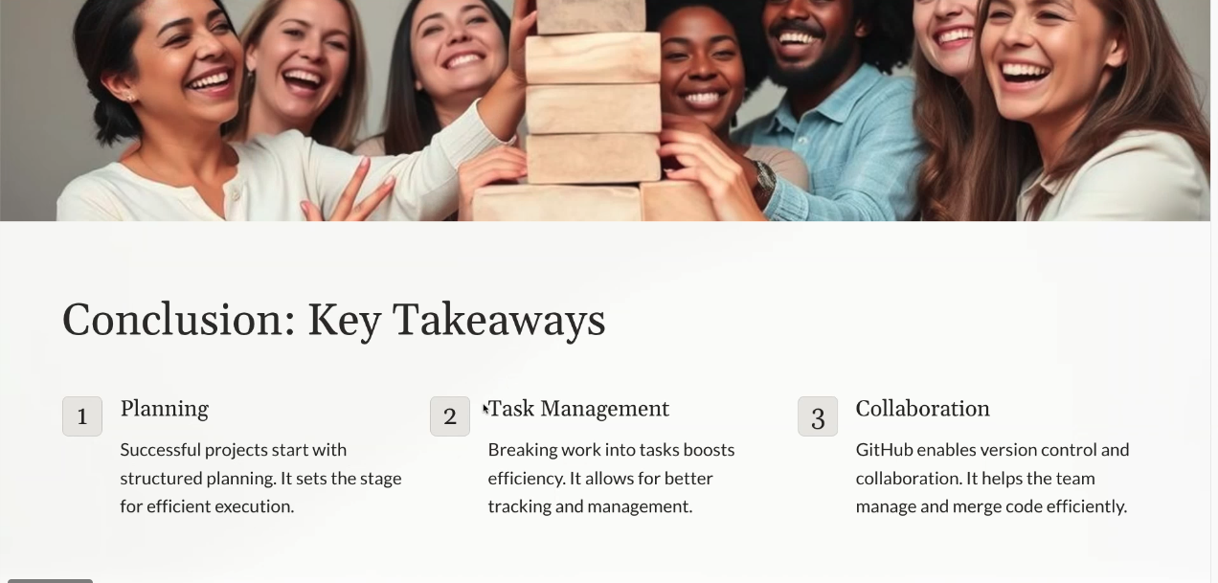

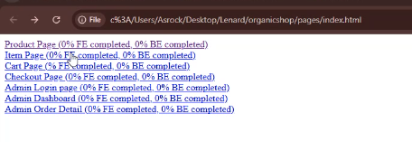

Simulate the page

Clickable prototypes (add to cart, remove product from cart)

Checkout

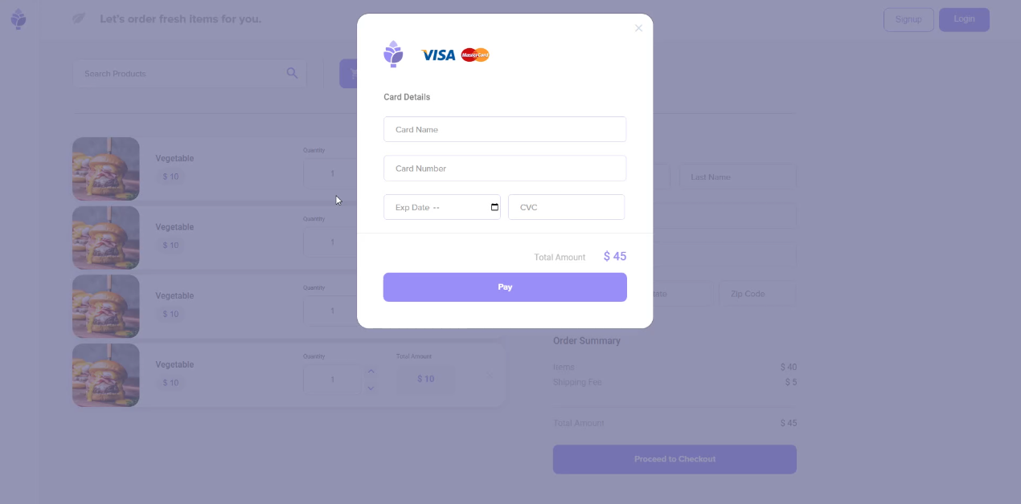

Data – predefined save in a variable fetch nalang object for user, cart product (js variables manage data)

Add comments to code above function or inside it depending on the complexity.